3.46: a) Integrating, 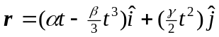. Differentiating, 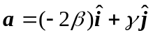.

b) The positive time at which 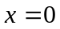 is given by 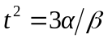. At this time, the y-coordinate is



